Adding a Notary
Notary Maintenance
Log into your Pavaso account and select My Company. These steps are for billing purposes, users still have to register as an eNotary. https://help.pavaso.com/wp-content/uploads/Registering_as_a_Pavaso_eNotary.pdf
Note: Notary Maintenance is only available to Company and Primary Administrators.

Select Edit for your company.
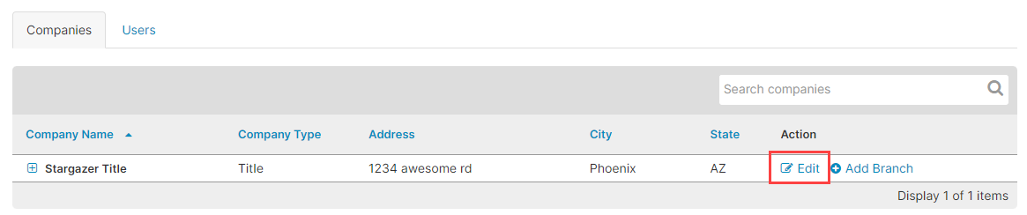

Select Notary Maintenance from the menu on the left side of the screen.
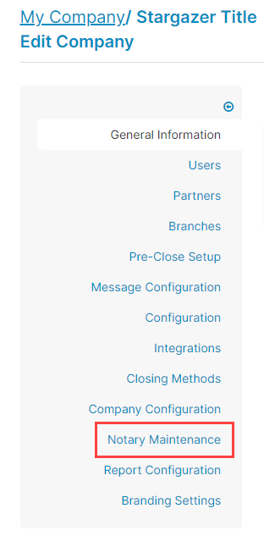
Select the Add User button.

Fill out the Notary’s information and select Add.
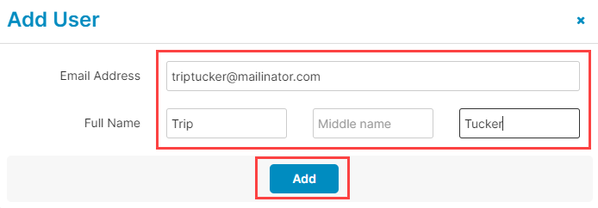

Select OK on the pop up.
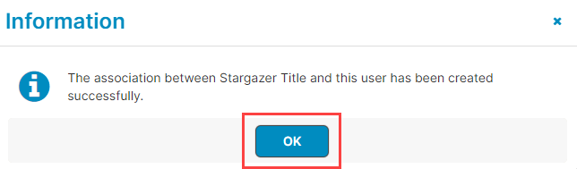

Auto-Renew Option
If you want the Notary billing to Auto-Renew, select the check box under the Auto-Renew section.
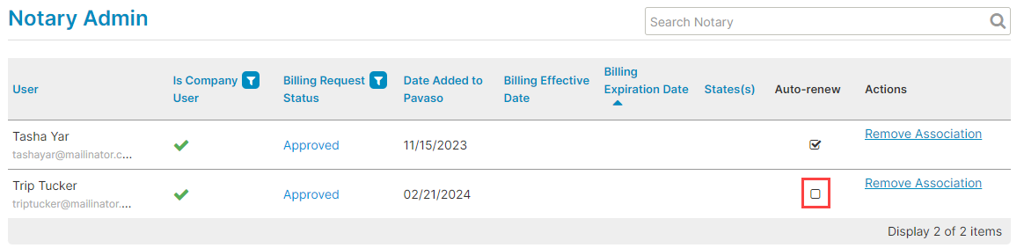

Removing a Notary
To remove a Notary, select Remove Association. Removing a Notary will remove them from your company and billing only and not affect their Notary account.
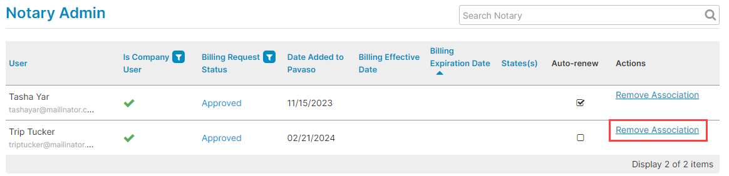

Notary Notification
If the Notary is a new user, they will be sent an email to set up their account. Existing Notaries will not get Notified.

Pavaso Support
Support Hours: https://pavaso.com/contact/
Phone/ Closing Hotline: (866) 288-7051
Email: support@pavaso.com
View Our 24/7 Online Help Library

